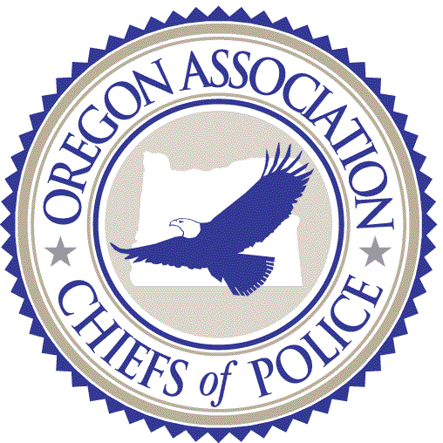

HISTORY OF THE PAUL NAGY AWARD

The Oregon Association Chiefs of Police was founded in 1953 with the intended purpose of enhancing the professionalism of Law Enforcement in Oregon. It was envisioned that the new association would promote training and information sharing to facilitate the professional growth of Chiefs of Police and Police officers state wide. The Oregon Association Chiefs of Police has always been a leader both on the state and national level in the effort to enhance the profession. The strength of an organization is found in the membership and those who give of themselves to better the whole. OACP is no exception and we have been fortunate to have many fine leaders who have worked tirelessly to meet the goals of the association and the needs of the citizens we serve.
The association has always attempted to recognize those members who have demonstrated the highest degree of leadership with high standards and efforts to assist OACP to meet its objectives and goals. Originally the highest award given was named the “Meritorious Service Award.” In 1989 the name of the Award was changed to the “Paul Nagy Award” in honor of the Chief of Police from The Dalles, who lost his battle with cancer.
Paul Nagy served the association in many capacities including several committees both in the Oregon Association Chiefs of Police but also representing OACP on IACP committees. Just prior to his death Paul was serving in the “Chairs” of this association where he served as President in 1987 and 1988. Paul Nagy was the epitome of a professional and a gentleman. Members who served with Paul remember him as the first to welcome new members. He shook their hands and made them feel at home. He was a tremendous person who had the respect of all who knew and worked with him. Paul Nagy was awarded the Meritorious Service Award by the Oregon Association Chiefs of Police on April 16, 1987. It was thought by the OACP Board of Directors that it would be fitting to name the top award after Paul. He exemplified the Highest Standards of Professionalism in Law Enforcement and the Association members voted unanimously to identify its highest award, The Paul Nagy Award.

HISTORY OF THE MAX PATTERSON AWARD

Max Patterson served as the Chief of Police for the City of Gladstone from 1981 until his untimely death on September 15th 1990. Max was very active in the Oregon Association Chiefs of Police serving on various committees and always offering his time and abilities. Max was a graduate of the FBI National Academy and understood the extreme value of the caliber of training offered to those who are fortunate enough to attend that training. Max also understood that not all Oregon Chiefs of Police were able to attend the FBI National Academy. As a result Max became dedicated to the concept of bringing FBI National Academy training to the Law Enforcement Executives of Oregon. Max was one of the driving forces behind the birth of the Oregon Executive Development Institute that hundreds of Law Enforcement leaders have been able to attend and receive world class training that would have otherwise been unavailable to them.
On April 12th 1990 Max was elected by his colleagues to serve as the OACP Secretary/Treasurer. Max was continuing his service to the organization and intended to continue through the chairs of leadership. Unfortunately he was taken from this world prematurely leaving a legacy of high standards, commitment to his family, community and law enforcement.
Max Patterson was awarded the “Meritorious Service Award” in April 1989. It was fitting that during an Oregon Association Chiefs of Police board meeting in 1991 the Max Patterson Award was created to honor his memory and recognize members of the association that make outstanding contributions to the OACP or to the community in presenting programs of outstanding benefit to young people of all ages.

SUMMARY
Upon the creation of the Max Patterson Award the OACP Board also decided that the new award would join the Paul Nagy Award as awards of equal value. The Board by unanimous vote made the Paul Nagy and Max Patterson Awards collectively the highest awards that can be awarded by the Oregon Association Chiefs of Police.

